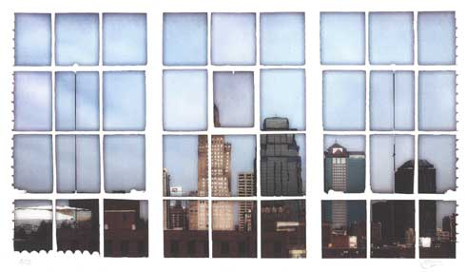
Environmental Management Commission
Meeting Minutes April 10, 2019
Meeting Location: Health Department, 2400 Troost Ave, KCMO

Commissioners present: Carol Adams, Bob Berkebile, Caroline (Molly) Davies, Michael Kelley, Julie Koppen, Marty Kraft, Meggie Mapes, Scott Klamm, Erika O’Shea, DJ Pierre, Ben Proffer

Commissioners Absent: Jensen Adams, Gloria Ortiz Fisher, Kimberly Hill, Nathan Madden, Joseph Nickels, Nacente Seabury

Staff: Andy Savastino and Jerry Shechter – OEQ; Katie Chandler – Law;

Guests: June Holte, Pachamama/Drawdown; Sarah Taylor, Dee Kim (?) – UMKC students;

- The meeting was called to order at 4:05 pm; A quorum was present. Co-chair Carol Adams welcomed commissioners, staff and guests. New Commissioner Erika O’Shea was welcomed as everyone introduced themselves.

- Minutes – Consideration of the minutes of the meeting of March 2019 was deferred to the next meeting.

- Bike KC Master Plan – draft 2019 – Michael Kelley described the draft plan and asked for a letter of support to be distributed to the Mayor and City Council to adopt the newly revised plan and that the Commission Chair be authorized to sign the letter on behalf of the Commission. Carol Adams made such a motion which was seconded by Bob Berkebile. The motion passed.

- Liaison Updates – No reports this month

- OEQ Report – Andy Savastino – No report

EMC Planning – Annual Report – Carol Adams led the discussion. It was highly suggested the cover letter of the report be shorter and more succinct, that it congratulate the Mayor and City Council for its achievements so far, and that a set of examples of best practices be collected that address the most critical issues. This could include affordable housing, etc. The question is what is missing from the current draft of achievements that should be highlighted for consideration?

Bob Berkebile offered an alternative core document to be the cover letter. He recommended that the originally proposed letter be moved to a supportive position with the large array of attachments. Carol Adams asked each Commissioner to take responsibility for a revised set of attachments and to review them for discussion at the May meeting. The balance of the meeting was used by Commissioners as a work session to review the newly revised set of attachments.

- Old Business – None

- New Business –
  - Marty Kraft noted he has organized a bio-char event for 4/12/19 at 2:00 pm at 5630 Tracy
  - Jerry Shechter noted there will be a screening of the film “Paris to Pittsburgh”, co-hosted by Unity Temple, UMKC and the City, at Unity Temple on the Plaza on 4/12/19 from 12:30 pm to 3:00 pm.

- Remarks from Visitors - None

The next EMC meeting is: | DATE: Wednesday, May 8, 2019  TIME: 4:00 pm  PLACE: KCMO Health Department – 2400 Troost; Suite 4600

The meeting was adjourned at 5:45 pm

