405 Ramps
405.1 General. Ramps on accessible routes shall comply with 405.
EXCEPTION: In assembly areas, aisle ramps adjacent to seating and not serving elements required to be on an accessible route shall not be required to comply with 405.
405.2 Slope. Ramp runs shall have a running slope not steeper than 1:12.
EXCEPTION: In existing sites, buildings, and facilities, ramps shall be permitted to have running slopes steeper than 1:12 complying with Table 405.2 where such slopes are necessary due to space limitations.

Table 405.2 Maximum Ramp Slope and Rise for Existing Sites, Buildings, and Facilities
Slope¹ | Maximum Rise
Steeper than 1:10 but not steeper than 1:8 | 3 inches (75 mm)
Steeper than 1:12 but not steeper than 1:10 | 6 inches (150 mm)
^{1.} A slope steeper than 1:8 is prohibited.
Advisory 405.2 Slope. To accommodate the widest range of users, provide ramps with the least possible running slope and, wherever possible, accompany ramps with stairs for use by those individuals for whom distance presents a greater barrier than steps, e.g., people with heart disease or limited stamina.
405.3 Cross Slope. Cross slope of ramp runs shall not be steeper than 1:48.
Advisory 405.3 Cross Slope. Cross slope is the slope of the surface perpendicular to the direction of travel. Cross slope is measured the same way as slope is measured (i.e., the rise over the run).
405.4 Floor or Ground Surfaces. Floor or ground surfaces of ramp runs shall comply with 302. Changes in level other than the running slope and cross slope are not permitted on ramp runs.
405.5 Clear Width. The clear width of a ramp run and, where handrails are provided, the clear width between handrails shall be 36 inches (915 mm) minimum.
EXCEPTION: Within employee work areas, the required clear width of ramps that are a part of common use circulation paths shall be permitted to be decreased by work area equipment provided that the decrease is essential to the function of the work being performed.
405.6 Rise. The rise for any ramp run shall be 30 inches (760 mm) maximum.
405.7 Landings. Ramps shall have landings at the top and the bottom of each ramp run. Landings shall comply with 405.7.
Advisory 405.7 Landings. Ramps that do not have level landings at changes in direction can create a compound slope that will not meet the requirements of this document. Circular or curved ramps continually change direction. Curvilinear ramps with small radii also can create compound cross slopes and cannot, by their nature, meet the requirements for accessible routes. A level landing is needed at the accessible door to permit maneuvering and simultaneously door operation.
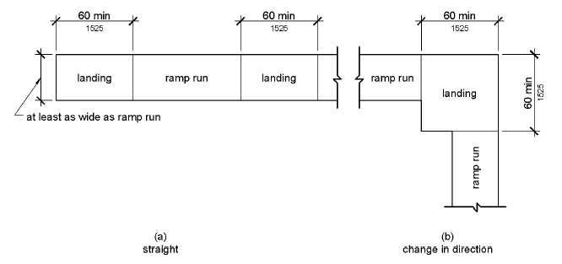
Figure 405.7 Ramp Landings
405.7.1 Slope. Landings shall comply with 302. Changes in level are not permitted.
EXCEPTION: Slopes not steeper than 1:48 shall be permitted.
405.7.2 Width. The landing clear width shall be at least as wide as the widest ramp run leading to the landing.
405.7.3 Length. The landing clear length shall be 60 inches (1525 mm) long minimum.
405.7.4 Change in Direction. Ramps that change direction between runs at landings shall have a clear landing 60 inches (1525 mm) minimum by 60 inches (1525 mm) minimum.
405.7.5 Doorways. Where doorways are located adjacent to a ramp landing, maneuvering clearances required by 404.2.4 and 404.3.2 shall be permitted to overlap the required landing area.
405.8 Handrails. Ramp runs with a rise greater than 6 inches (150 mm) shall have handrails complying with 505.
EXCEPTION: Within employee work areas, handrails shall not be required where ramps that are part of common use circulation paths are designed to permit the installation of handrails complying with 505. Ramps not subject to the exception to 405.5 shall be designed to maintain a 36 inch (915 mm) minimum clear width when handrails are installed.
405.9 Edge Protection. Edge protection complying with 405.9.1 or 405.9.2 shall be provided on each side of ramp runs and at each side of ramp landings.
EXCEPTIONS:
1. Edge protection shall not be required on ramps that are not required to have handrails and have sides complying with 406.3.
2. Edge protection shall not be required on the sides of ramp landings serving an adjoining ramp run or stairway.
3. Edge protection shall not be required on the sides of ramp landings having a vertical drop-off of 1/2 inch (13 mm) maximum within 10 inches (255 mm) horizontally of the minimum landing area specified in 405.7.
405.9.1 Extended Floor or Ground Surface. The floor or ground surface of the ramp run or landing shall extend 12 inches (305 mm) minimum beyond the inside face of a handrail complying with 505.
Advisory 405.9.1 Extended Floor or Ground Surface. The extended surface prevents wheelchair casters and crutch tips from slipping off the ramp surface.
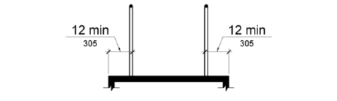
Figure 405.9.1 Extended Floor or Ground Surface Edge Protection
405.9.2 Curb or Barrier. A curb or barrier shall be provided that prevents the passage of a 4 inch (100 mm) diameter sphere, where any portion of the sphere is within 4 inches (100 mm) of the finish floor or ground surface.

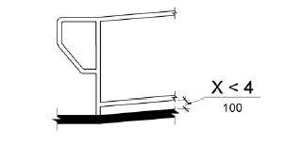

405.10 Wet Conditions. Landings subject to wet conditions shall be designed to prevent the accumulation of water.

406 Curb Ramps
406.1 General. Curb ramps on accessible routes shall comply with 406, 405.2 through 405.5, and 405.10.
406.2 Counter Slope. Counter slopes of adjoining gutters and road surfaces immediately adjacent to the curb ramp shall not be steeper than 1:20. The adjacent surfaces at transitions at curb ramps to walks, gutters, and streets shall be at the same level.
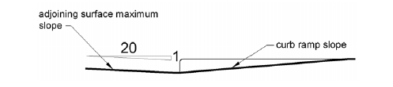
Figure 406.2 Counter Slope of Surfaces Adjacent to Curb Ramps
406.3 Sides of Curb Ramps. Where provided, curb ramp flares shall not be steeper than 1:10.
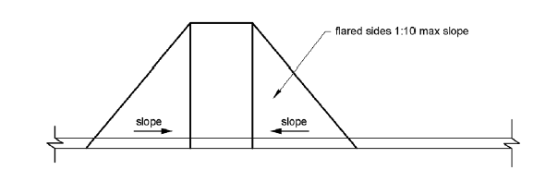
Figure 406.3 Sides of Curb Ramps

406.4 Landings. Landings shall be provided at the tops of curb ramps. The landing clear length shall be 36 inches (915 mm) minimum. The landing clear width shall be at least as wide as the curb ramp, excluding flared sides, leading to the landing.

Public Accommodations and Commercial Facilities (Title III)
Title III prohibits discrimination on the basis of disability in the activities of places of public accommodations (businesses that are generally open to the public and that fall into one of 12 categories listed in the ADA, such as restaurants, movie theaters, schools, day care facilities, recreation facilities, and doctors' offices) and requires newly constructed or altered places of public accommodation—as well as commercial facilities (privately owned, nonresidential facilities such as factories, warehouses, or office buildings)—to comply with the ADA Standards.

TITLE III REGULATIONS
Revised Final Title III Rule: A Compilation of Regulatory Provisions and Guidance -- Nondiscrimination on the Basis of Disability by Public Accommodations and in Commercial Facilities | PDF
This document contains the following: (1) supplementary information (the preamble to the revised regulation); (2) the title III regulation updated to reflect the 2010 revisions and the technical corrections (published March 11, 2011) which became effective on March 15, 2011; (3) guidance on the revised regulatory provisions; and (4) guidance on the original 1991 title III regulation.
28 CFR Part 36 -- Nondiscrimination on the Basis of Disability by Public Accommodations and in Commercial Facilities (Electronic Code of Federal Regulations)

ADA STANDARDS FOR ACCESSIBLE DESIGN
2010 ADA Standards for Accessible Design | PDF screen | PDF print
Scoping and technical requirements for new construction and alterations and for use in removing accessibility barriers in existing places of public accommodation when doing so is readily achievable.
Guidance on the 2010 ADA Standards for Accessible Design | PDF screen | PDF print
This explanatory information addresses the scoping and technical provisions of the 2010 Standards.

TECHNICAL ASSISTANCE MATERIALS -- 2010 REVISED REGULATIONS
ADA Update: A Primer for Small Business | PDF
An illustrated guide to help small businesses understand the new and updated requirements of the revised ADA regulations.
Revised ADA Requirements: Effective Date and Compliance Date | PDF
This publication sets out several different "compliance dates," dates by which entities covered by the ADA are required to comply with the new or revised provisions of the Department's rules.
Revised ADA Requirements: Accessible Pools - Means of Entry and Exit | PDF
This publication is designed to help title II and title III entities understand how new requirements for swimming pools, especially existing pools, apply to them.
Questions and Answers: Accessibility Requirements for Existing Swimming Pools at Hotels and Other Public Accommodations
Revised ADA Requirements: Ticket Sales | PDF
This publication provides guidance on the Department's new nondiscrimination requirements that apply to selling tickets for assigned seats at events such as concerts, plays, and sporting events.
Revised ADA Requirements: Service Animals | PDF
This publication provides guidance on the term “service animal” and the service animal provisions in the Department’s new regulations.
More Technical Assistance Materials

FILING AN ADA COMPLAINT
How to File a Title III Complaint | PDF
This publication details the procedure for filing a complaint under title III of the ADA, which prohibits discrimination based on disability by businesses and non-profit agencies.
Frequently Asked Questions About Filing an ADA Complaint

OTHER RESOURCES
Title III Cases and Matters
Title III Technical Assistance Publications (1991 Regulations)

Additional:

Figure 16. Components of a Single Ramp Run and Sample Ramp Dimensions.
Components include a level landing at the top of the ramp, the surface of the ramp and a level landing at the bottom of the ramp. The rise of the ramp is the vertical dimension and the horizontal projection or run of the ramp is the horizontal dimension. If the slope of a ramp is between 1:12 and 1:16, the maximum rise shall be 30 inches (760 mm) and the maximum horizontal run shall be 30 feet (9 m). If the slope of the ramp is between 1:16 and 1:20, the maximum rise shall be 30 inches (760 mm) and the maximum horizontal run shall be 40 feet (12 m).

